**Multiclass Fish Image Classification**

# **Data Preprocessing:**

**Images are loaded and rescaled to the range of 0 to 1. They are then randomly rotated, shifted horizontally and vertically, zoomed, and flipped. Missing pixels resulting from these transformations are filled. Finally, the image size is specified.**

**Model Training:**

**Training various models, including CNN, VGG16, ResNet, MobileNet, and InceptionV3, resulted in MobileNet demonstrating superior performance with an accuracy of 0.9926 and a loss of 0.0250. This trained MobileNet model was then saved to a pickle file.**

**Model Evaluation:**

**Metrics, including accuracy, precision, recall, and F1-score, were compared across all models. Additionally, the training history (accuracy and loss) for each model was visualized.**

**Accuracy plot:**

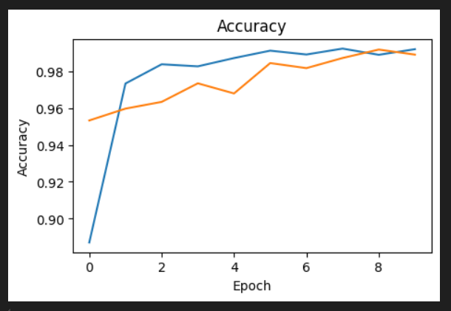

**Loss plot:**

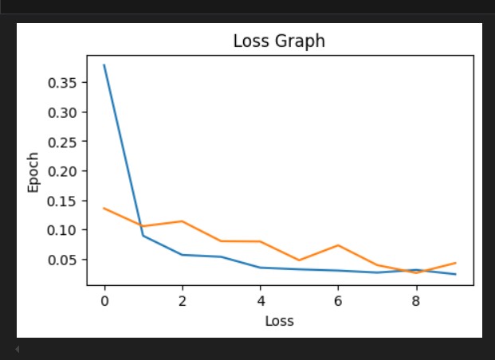

**Same like the above graphs I have created for all models.**

**Deployment in Streamlit:**

**Build a Streamlit application that allows users to upload fish images, it predict the class and displays the fish category, and confidence scores.**

**The below images shows the home page and visualization of the streamlit web.**

